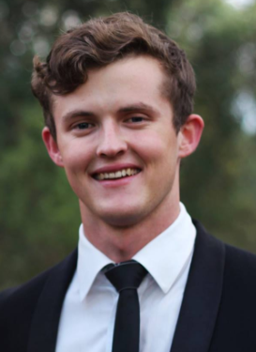
Brendon Davis

Personal Details:
Date of birth - 28/01/1995
Gender - Male
Citizenship – South African

Motivational Statement:

I am a diligent learner and commit myself to hard work and further personal growth. I aspire to make a just contribution to society and agricultural sustainability.

Contact details:
Email address – 18860648@sun.ac.za
Mobile number - +27848214558

Education:

- Matriculated at Paarl Boy’s High School in 2013.
- Stellenbosch University. Currently in final year of a four year degree, studying a Bachelor of Animal Science with Aquaculture.

Related Employment History and Voluntary Work:

- Internship work at ‘Roman Bay Abalone Farm’, Gaansbaai, Western Cape. I spent my entire July break in 2015 working mostly in the hatchery section of this large scale abalone farm operation. During this time, I learnt a great deal of how South Africa has progressed in the abalone industry.

- Throughout my time at Stellenbosch University I have made myself available to all the aquaculture Masters and PhD students to assist in their research. As a result, I have been involved in several trials conducted on the university’s experimental farm.

- In 2017, I attended and worked at the World Aquaculture conference held in Cape Town. At the conference my position was in the admin department, working under the head organizer ‘Mario Stael’ who has been organizing the WAS conference for the past few years. As a young student, this was a great opportunity for networking and gathering an understanding of the current global scale of aquaculture.

Unrelated Employment History:

- Vrede en Lust - Wine Farm & Estate. Worked as a runner during December holiday season 2012.
- Noble Hill - Wine Estate. Worked as a waiter in November/December 2013.
- Maidwell Hall School, Northampton, UK - I spent my year abroad working at this private boarding school as a Gap Tutor. I was employed from January the 4th until December the 9th 2014.
- Boschendal – Wine Estate. Worked as a waiter in the Werf restaurant over December 2014/January 2015
- ASAP staffing – 2015-2017. I’ve worked as a waiter at various events, mostly weddings.
- Thelema Wine Estate -2018. I’ve started part time work in the wine tasting room to earn extra money as a student.
Personal Interests:
I have a serious passion for the outdoors. I enjoy hiking, surfing and fishing in my spare time. I’ve grown to appreciate travelling in recent years. In 2014 I was privileged to be able to go overseas on a self-funded gap year where I earned my keep whilst working at Maidwell Hall in England. This job also provided me sufficient funds to go travelling during the school holidays. Being able to visit numerous countries in Europe, I was able to embrace a variety of cultures that came with the experience. This helped me to broaden my mind and grow independently, which made my university experience a lot easier in my opinion.
I also thoroughly enjoy endurance challenges and adventures. I’ve competed in half marathons as well as trail runs in the Western Cape. I’ve organized overnight group hikes with friends, some of which lasted for 6 days in length. My most recent and greatest personal achievement was an unassisted cycle tour for charity that I completed with two other friends during our July break. Over the space of 3 weeks we cycled from Inverness to London, covering a distance of roughly 1500km. This trip took well over a year to plan and save up for, which made crossing the finish line the most rewarding experience.

References:
Dr Khalid Salie – ks1@sun.ac.za
Mr Henk Stander – hbs@sun.ac.za
-Additional references available upon request.

