Curriculum Vitae

DEEPAK KUMAR ADDRESS - VILL. Lankura ,P.O- Kelakhera
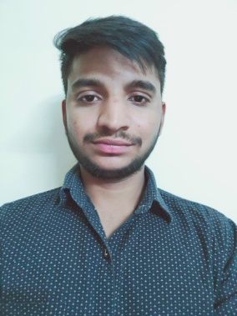
U.S. Nagar Uttarakhand, 263150
Contact no: - +917055468823,
Email: -deepak2006933@gmail.com

Career Objectives

I want to get a job in private sector . where I can develop my management skills, technical skills, practical knowledge, teamwork spirit, strength and confidence for the future career.

Work Experience
- 4 year work experience in a NGO (C.H.E.T.N.A Student wing Pantnagar).it is a Delhi based NGO. Which is work for underprivileged children’s and Women’s .
- 7 Days work experience in Fish Post harvest Management in Reef berry foodexpvt. LTD. Gujarat.
- 6 months experience in Aqua farming at College of Fisheries Pantnagar U.S. Nagar
- 1 year experience of Practical Fish Production at College of Fisheries Pantnagar U.S. Nagar

Academic Snapshot
Examination | Board | Passing Year | % Marks/ OGPA | Division
B.F.Sc. (Fisheries science) | GBPUA&T, Pantnagar | 2016-2020 | 7.8 | 1st
XII | Uttarakhand Board | 2016 | 83.8 | 1st
X | Uttarakhand Board | 2014 | 72 | 1st

Awards & Certifications
- Vice President in CHETNA Student Wing Pantnagar
- University athletic team Captain .
- 2 year member of university team ( athletics and wrestling )
- Gold medalist in Wrestling (University level).
- General Secretary of fisheries Society in 3rd year.
- Class representative in 1st year and also in the 4th year .
- NCC ‘B’ certificate .
- Awarded third prize in skit competition.
- Runner up in hockey tournament.
- Basic knowledge of computer (3 months diploma ).
Hobbies & Strength
- Dancing and listening music .
- Quick learner with a practical bent of mind.
- Self motivated with out of the box thinking.
- Team worker.
- An effective communicator with strong interpersonal & problem solving skills.
- Has a good practical hand in computer operating.
- Learning various National & International Languages.
- Playing games.

Personal Information

- Name Deepak kumar
- Father’s name Mr. Roshan Lal
- Mother’s Name Mrs. Mahawati Devi
- Siblings 2 elder brothers and one sister
- Sibling Status 1 brother is in Uttarakhand Homeguards and one is still studying .
- Date of Birth 28th july 1999
- Languages known Hindi, English, Punjabi
- Nationality Indian
- Sex Male
- Marital Status Bachelor

ANY OTHER RELEVANT INFORMATION:
Visited in All India educational tour (AIET),And also participated in a training program on Industrial fisheries.

DECLARATION : I hereby declare that all the information given above is true to the best of my knowledge and belief.

