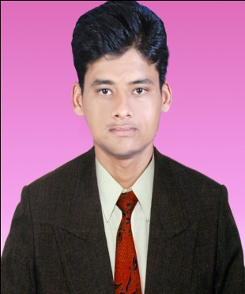
CURRICULAM-VITAE

DINESH SAHU.

AT- MAIN ROAD, PO- GOPALPUR (ON-SEA)

GANJAM, ODISSHA-761002, (INDIA)

DATE OF BIRTH-01.07.1985

GENDER- MALE

MARITAL STATUS-UN-MARRIED

NATIONALITY -INDIAN

LANGUAGES KNOWN -, ENGLISH, ARBIC, HINDI, BANGOLI, ODIA & TELUGU

ACADEMIC PROFILE- GRADUATION

CONTACT INFORMATION-

+917205405800( IND ),
+966-501860174(KSA)
EMAIL-dineshsahu85@gmail.com

To be a part in your organization where I can make a significant mark by viture of my hard work and innovative skills

I worked as an Aquaculture Asst tecnician since 2015 to till date and produced more then 550 million shrimp seeds ( p.mondon )in different parts of India produced more then 150milon seeds ( L.vanami )

Dinesh Sahu

JOB RESPONSIBILIT:--

- SEA WATER TREATMENT
- ALGAE CULCHAR: - C.C & SKT
- MATURATION: - BROOD STOCK REARING, EYE STALK ABLATION, NAUPALLI PRODUCATION
- LARVAL REARING.
- POST LARVAL REARING.
- ARTEMIA CULCHAR.
PROFESINAL INTERESTS:--

PRODUCE & DELIVAREY THE SPECIFIED PATHGNES FREE FRY TO GROW OUT.

IMPROVE THE SURVIVAL RATE FROM NAUPALLI STAGE TO PL-15.

EVALUTION OF BROODSTOCK QUALITY DURING THE COLLECTION TIME
, EYE STALK ABLATION,
SELECTION OF SPAWNERS/ GRAVIDS,
MONITARING THE WATER PARAMETERS,
MANTAIN THE FEED MANAGMANT,
EGGS COLLECTION FROM SPAWNING TANK,
EGGS WASHING & COUNTING OF FERTILLIED EGGS,
NAUPALLI COUNTING.

ALGAE CULCHAR:-- MANTAIN INDOOR, OUTDOOR C.C & SKT ( F/2, F/4 ) MEDIA.

CAEER OBJECTIVE: --

Deep sun Hatchery, Orissa (10th Feb- 2014 to 2016).

National Aquaculture Group , Kingdom of Saudi Arabia (21Feb -2017 to till Continue).

REFERENCE:--

MR. VENU GOPAL( MANAGING DIRECTOR ) DEVI SEA FOODS, A.P INDIA.

MR. SANJAY KUMAR MOHANTEY (MANAGING DIRECTOR) DEEP SUN, ORISSA INDIA.

I solemnly declare that the above furnished information is true and correct to the best of my knowledge and belief.

Dinesh Sahu.

