Curriculum Vitae
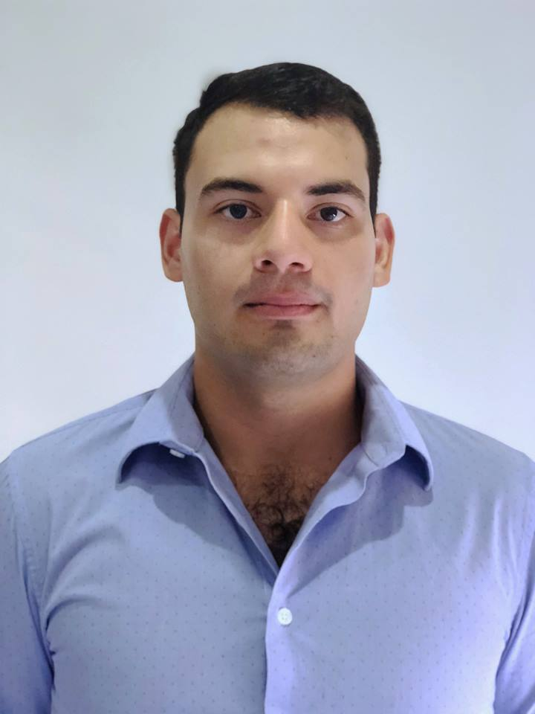
Surname, First name: Cárdenas, Lino Xavier
Adress: Portal del Sol, Via Barbasquillo, Manta; Ecuador
Mobil: +593-0997873276
E-mail: cardenaslino94@gmail.com
Nationality: Ecuadorian/Italian
Date of birth: November 24 , 1994

EDUCATION

- Zamorano University (January, 2014 – December, 2017)
  - Bachelor of Science in Agribusiness Management
  - GPA: 3.38
- Leonardo da Vinci ( January, 2011- December, 2013)
  - High school graduation
  - Specialization in Commerce and Management
  - Grade: 9.1

Other skills

- Microsoft Office
- @Risk
- SAS (Analytics Busines Intelligence and Data Management)
- Languages:
  - Spanish (Native)
  - English (Advanced)
  - Italian (Basic)

COURSES AND sEMINARS

- COURSES
  - Molecular diagnosis for Shrimp Pathologies, Universidad Espíritu Santo, Ecuador
  - Master Trading, focused on FOREX, Trading Society CO, Ecuador
  - Synthetic Biology, Zamorano University, Honduras
  - Cambridge English Certificate, Level B2, Manta, Ecuador

- SEMINARS
  - Euroshrimp 2017, Bremen, Germany
  - Aquafarm 2017, Udine, Italy
  - Congreso Regional de Economía, Administración y Negocios (CREAN) 2016, Honduras
  - Honduras Startup 2016
  - Congreso Regional de Economía, Administración y Negocios (CREAN) 2015, Honduras

Working experience

- Grupo Nueva Pescanova, Marfrisco, Naranjal ; Ecuador (June, 2019 – Present)
  - Production Assistant, Shrimp Farming
  - Nursery/Raceways Management

- LARDEMA, Manta, Ecuador (January, 2018 – June, 2019 )
  - Production Assistant, Shrimp Larvae Production

- Processing Plant, Zamorano University, Honduras (May, 2017 – November, 2017)
  - Production and Cost Manager, Fruit and Vegetables Processing

- Eco-Farming, Padua, Italy (January, 2017 – April, 2017)
  - Production Assistant, Shrimp Farming / Internship

