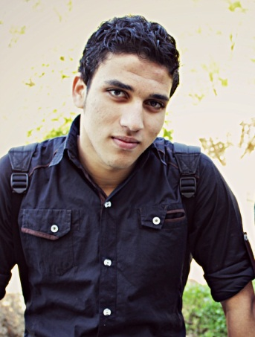
Personal Data:
Address : Talkha-Mansoura-EL Diqhlya-Egypt
Mobile : 01102477867
E.Mail : mohamedahmed199497@yahoo.com
mohamedahmed199497@gmail.com
Date of birth : 6/9/1994
military stage : finished yet
stage : graduated
ـــــــــــــــــــــــــــــــــــــــــــــــــــــــــــــــــــــــــــــــــــــــــــــــــــــــــــــــــــــــــــــــــــــــــــــــــــــــــــــــــــــــــــــــــــــــــــــــــــــــــــــــــــــــــــــــــــــ
Education:
- Graduated from suez university
- Faculty of fish resources and marine science
- Aquaculture engineering program & hatching program
- Graduation grade : GPA 2.79
- Graduation project : pre-pilot design of clams hatchery and culture
ـــــــــــــــــــــــــــــــــــــــــــــــــــــــــــــــــــــــــــــــــــــــــــــــــــــــــــــــــــــــــــــــــــــــــــــــــــــــــــــــــــــــــــــــــــــــــــــــــــــــــــــــــــــــــــــــــــــ
Work Experience:
Role | Duration | Organization
The supervisor of marine hatchery  ( the largest hatchery in the middle east ) | 14-1-2017 to 20-2-2018 | The national company for fisheries and aquaculture ( berkt gheleon )  ) بركه غليون )
The supervisor of the farm | 20-6-2015 to 25-8-2015 | Private farm sector
Courses:
Place | Date | Course title
Mansoura university | 25-9-2016 | ICDL
Mansoura university | 2-10-2016 to 28-11-2016 | English course 6 levels
Mansoura university | 1-3-2018 | Social media marketing by sponsor ads
Suez | 22/12/2015 | Applied practices for breeding and hatching of nile tilapia in frameworks of ITACA project (improved management and technological innovation in africian tilapia farms and hatcheries)
In The College Of Agriculture, Alexandria University and the hatchery kilo 21 and hatchery sharif | 28/4 2016 to 1/5 2016 | Modern Techniques in shrimp and marine fishes hatching, with a Visit To The Hatchery Kilo 21 And Hatchery –Sharif.
Port said | 28/3/2016 | Course In Aquaculture In Port Said Problems And The Role Of Scientific
suez | 2/12/2015 | The ( IOI ) future vision of aquaculture  In Egypt
Skills:
Language skills
- Arabic : Native language
- English : Good command of listening & speaking & writing
Computer skills
- Very good user of Microsoft office package (Power point, Excel and word)
- Able to use many statistic programs (SAS, SPSS and Microsoft office excel).
- Beginner user of the remote sensing program the ARC map
ـــــــــــــــــــــــــــــــــــــــــــــــــــــــــــــــــــــــــــــــــــــــــــــــــــــــــــــــــــــــــــــــــــــــــــــــــــــــــــــــــــــــــــــــــــــــــــــــــــــــــــــــــــــــــــــــــــــ
Official visits:
- a visit to national authority for remote sensing & space sciences
- a visit to Egyptian meteorological authority
- visits to( farms – hatcheries – research centers ) during the four years studying in the faculty
ـــــــــــــــــــــــــــــــــــــــــــــــــــــــــــــــــــــــــــــــــــــــــــــــــــــــــــــــــــــــــــــــــــــــــــــــــــــــــــــــــــــــــــــــــــــــــــــــــــــــــــــــــــــــــــــــــــــ
Sport certificates:
- third ranked in quintets football at the level of republic in Mansoura 2014/2015
- third ranked in quintets football at the level of suez university
- first ranked in quintets football at the level of faculty of fish resources and marine sciences
- second ranked in quintets football at the level of faculty of fish resources and marine sciences
the best player at the level of universities republic in kafr elsheikh university -
ـــــــــــــــــــــــــــــــــــــــــــــــــــــــــــــــــــــــــــــــــــــــــــــــــــــــــــــــــــــــــــــــــــــــــــــــــــــــــــــــــــــــــــــــــــــــــــــــــــــــــــــــــــــــــــــــــــــ
Personal skills:
- hard worker - committed person - team working skills
- high ability to work efficiently and actively under pressure
- high ability to make relationships and interactions with the others
- problem solving – social intelligence – flexibility – creativity
- communication skills – marketing and publicity
ـــــــــــــــــــــــــــــــــــــــــــــــــــــــــــــــــــــــــــــــــــــــــــــــــــــــــــــــــــــــــــــــــــــــــــــــــــــــــــــــــــــــــــــــــــــــــــــــــــــــــــــــــــــــــــــــ
Objectives:
Utilizing & enhancing my skills & qualifications through a big organization which encourage continuous education & development of its employees & through which I can interact & work creatively in a dynamic environment to prove myself as successful person by cooperation with my college & my supervisors.

