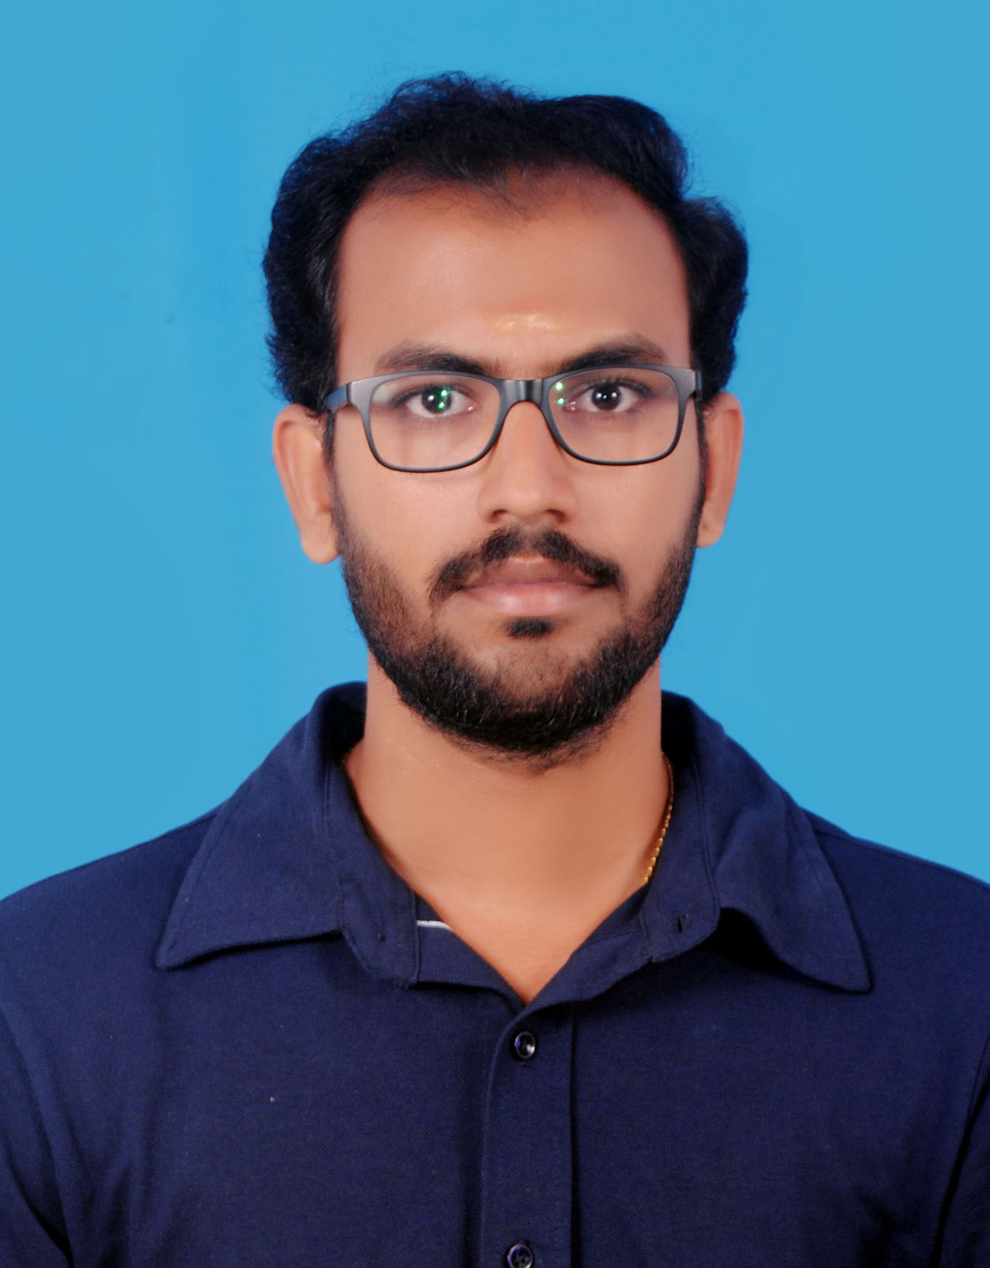

**DR. V. THANAPPAN**

**Career Objective**

An experienced Marine Biologist, expertised in coral translocation & restoration through latest Biorock technology and all other traditional methods for 4.10 years; and over 9.3 years of experience in marine research. Passionate PADI Divemaster with over 600+ logged dives.

**+ 91-7904383191**

**+ 971 545223134**

[**vthanappan57@gmail.com**](mailto:vthanappan57@gmail.com)

***PERMANENT ADDRESS***

Door No. 4/81

North Street

Arumanalloor (PO)

Kanyakumari District

Tamil Nadu, India.

Pin – 629 851

***RESIDENTIAL ADDRESS***

The Private Dept. of the President.

Aquaculture and Marine Studies Center (AMSC)

Station No. 3

Abu Al Abyad Island

United Arab Emirates (UAE)

Abu Dhabi.

**CONTACT**

Got trained in **Biorock Technology** from Dr. Tom Goureau, who is one of the 2 inventors & patentees of the techonology. Was working as the part of the team, which instatlled India’s and UAS’s **first Biorock reef.** Played a key roles in the deployment and installation of the biorock structures; and montiong and maintaining **6** biorock reefs till todate. The India as well as UAE’s largest coral translocation projects lead by me as the administrative in-charge, I am actively managing different dimensions of the team, and translocated so far about 7,500m2 area coral colonies and post-translocaiton monitoring successfully. I have my expertise in coral reefs Bio-physical monitoring, coral bleaching and its health assessment. I seek to associate with the scientific and marine industry in a challenging and team-oriented environment; leveraging my expertise of **Biorock technology** for sustainable management of coral reefs, Oyster reefs, Sponges, Gorgonians, Seaweeds, Sea grass and fish assemblages which is connives oceanic conservation measures.

Expertise in both Phytoplankton as well as Zooplankton Taxonomy, their diversity assessment for sustainability, Mangrove plantation and Carbon flux monitoring on the Pichavaram mangrove forest. I trained local fishermen communities on seaweeds mass culture techniques (during my PhD tenure). Surveying turtles and various other sea mammals have broadened my experience in marine environment. Fascinated in designing and maintaining aquarium tanks. Maintained wetlabs and larger aquarium tanks for experimental fishes, seaweeds, gorgonians and soft corals at the University Dept. lab.



* *LEADERSHIP*
* *TEAMWORK*
* *HANDLING PRESSURE*
* *COLLABORATION*
* *PROBLEM SOLVING*
* *ORGANIZATION*
* *COMMUNICATION*

Through my previous work experience in Environmental Impact Assessment (EIA), roles such as Screening, Scoping, Collection of baseline data, Impact prediction, Mitigation measures and EIA reports, Decision making, Monitoring, plant canopy management, soil analysis through instrumental strategies and implementation of the environmental management plan were executed under my guidance.

**EDUCATION AND QUALIFICATION**

**TECHNICAL SKILLS**

* **Ph.D.**in Marine Biology and Oceanography **(Awarded on 8th October 2020)** – Centre of Advanced Studies in Marine Biology, Faculty of Marine Sciences, Annamalai University,Chidambaram,Parangipettai, Tamil Nadu, India.
* SCUBA (Divemaster)
* CORAL REEF RESEARCH
* BIOROCK TECHNOLOGY
* RESEARCH DESIGN
* DATA COLLECTION
* MANUSCRIPT WRITING
* LAB ANALYSIS
* STATISTICAL ANALYSIS
* *AGAL RESEARCH*
* **Master of Science** in Marine Biology and Oceanography **(80%) 2014** – Centre of Advanced Studies in Marine Biology, Faculty of Marine Sciences, Annamalai University, Chidambaram, Parangipettai, Tamil Nadu, India.
* **Bachelor of Science** in Zoology **(62%) 2012** – Arignar Anna College, M.S. University, Aralvaimozhi, Tamilnadu, India
* **HSC –** State board, Arumanalloor, Tamil Nadu, India (March 2009).

**PERSONAL SNIPPET**

* **SSC –** State board, Arumanalloor, Tamil Nadu India (March 2007).

Name: V. Thanappan

Gender: Male

DOB: 15/07/1992

Marital Status: Married

Father’s Name:VelukavalPerumalPillai

Mother’s Name: B. Santhi

Nationality: Indian

Languages Known: Tamil,

English, Malayalam, and Hindi

**DOCTORAL THESIS**

Curriculum thesisatCentre of Advanced Study in Marine Biology, Annamalai UniversityundertheguidanceofProf.Dr. P.Anantharamanonthe following topic:

**“Seasonal Assessment and Assemblages of Phytoplankton at Parangipettai Coast and Influence of Different Light Intensity on Pigment Profile”**

**UNDER & POSTGRADUATION PROJECTS**

**PG Dissertation topic:**

* “Distribution of Edible Seaweeds in Kanyakumari Coast and its Utilization for Food Recipes”

**UG Dissertation topic:**

* “VERMICULTURE”, Vermicompost is taken from food and other natural waste (Earthworm fertilizer)

**COMPUTER SKILLS**

* MS Office
* PGDCA
* DPT (Photoshop
* System hardware & software skills
* Data Management

**PROFESSIONAL EXPERIENCE**

* **INSTITUTION: The Private Dept. of the President, Aquaculture and Marine Studies Center, Abu Al Abyad, United Arab Emirates (UAE) Abu Dhabi. (**Duration: **June 2023** to **Present**)
* **Designation: Marine Biology Specialist (In-charge)**
* **Project Location:** Al Yasat and Abu Al Abyad Islands in UAE.
* **Project:** Development of coral reef restoration project In Al Yasat and Abu Al Abyad Islands
* **Key responsibilities:** As the administrative in-charge, I actively managing different dimensions of the team, and execution of the **Biorock** technology in a larger prospect for the **first time in UAE** was performed in this project where I played a key role in the deployment and installation of the biorock structure.
* **INSTITUTION: ZSI – Zoological Survey of India (**Duration: **July 2021** to **June 2023** **– 1 year 11 months**)
* **Designation: Research Associate (RA-I)**
* **Project Location:** Narara, Marine National Park - Gulf of Kachchh, Gujarat, Jamnagar, India.
* **Project:** “Translocation and rehabilitation of True Corals falling in the excavated Intertidal and Subtidal Areas of the Project for Replacement of offshore Pipeline from Narara bet to SPM”
* **Key responsibilities:** This project is India’s largest coral translocation project where the activities of the team were led by myself. As the administrative in-charge, I was actively managing different dimensions of the team, and we had translocated about 15000+ coral colonies successfully and presently montoring them magnificently.
* **INSTITUTION: ZSI – Zoological Survey of India** (Duration: **Feb 2019 to July 2021 – 2 Years 5 months**)
* **Designation: Senior Research Fellow (SRF)**
* **Project:**“ Restoration of reefs using Electricity – A suitable technology to enhance and conserve Gulf of Kachchh reefs”
* **Project Location:** Marine National Park - Gulf of Kachchh, Gujarat, Jamnagar, India.

**REFERENCES**

* **Key responsibilities:** Execution of the biorocktechnology in a larger prospect for the **first time in India** was performed in this project where I played a key role in the deployment and installation of the biorock structure. Under the guidance of eminent scientist Tomas Goreau in 2022, aced in its electrical connectivities.
* **Dr. R. Chandran**

Scientist -C

Zoological Survey of India

Kolkata, India

Mob No: +91 78180 46452

* **Dr. Thomas J. Goreau,**

President, Global Coral Reef Alliance

BIOROCK® technology

* **Dr. Rajkumar Rajan**

The Principal Investigator, Scientist -E

Zoological Survey of India

MBRC

130 Santhome High Road

Raja Annamalai Puram, Chennai-600 028

Mobile No: + 91 9445395077

* **Dr. Ch. Satyanarayana**

The Principal Investigator, Scientist -C

Zoological Survey of India

MBRC

130 Santhome High Road

Raja Annamalai Puram, Chennai-600 028

Mobile No: + 91 9433325559

* **Prof. P. Anantharaman**

Professor

CAS in Marine Biology,

Annamalai University

Parangipettai - 608 502

[panantharaman@gmail.com](mailto:panantharaman@gmail.com)

Mobile: +91 9994545903

Further, I have monitored the deployed Biorocks since its depyment and I’m capable of designing strategies to increase its efficiency. I have manifested the biorock technology not only with corals but also pearl oysters, sponges, gorgonians, seaweeds and fish assemblages.

* **INSTITUTION: SAC- ISRO Ahmedabad (**Duration:**Feb 2016 – Mar 2018 – 2 Years 1 month**)
* **Designation: Junior Research Fellow (JRF)**
* **Project:** “Determination of specific absorption coefficient for the dominant microalgal species of the east coast of India – A step towards developing community-based chlorophyll and accessory pigment algorithm”
* **Project Location:** CAS in Marine Biology, Annamalai University, Tamil Nadu, India.
* **INSTITUTION:M.S. Swaminathan Research Foundation (MSSRF) (Duration:**June 2015 – December 2015 – **6 Months**)
* **Designation: Project Associate**
* **Project:** Artificial Coral reef plantation and Carbon flux monitoring on pichavaram mangrove forest
* **Institution Location:**Chidambaram, Tamil Nadu, India.
* **INSTITUTION:Infinity SCUBA** (**9 years diving experience**)
* **Designation: Divemaster** (License Nos.)

SCUBA Diving Master:400263

* Open Water :1610AD5477
* Advance Open Water :1610AD5650
* EFR :1610AD7229
* Rescue :1610AD7250
* **Institution Location:**Andaman Island, India

**RESEARCH INTEREST**

A Scuba diving Master seeking to tutor pupils in scuba diving and has conducted diverse research works in the field of:

* Marine biology and coastal biodiversity, with special reference to monitoring water quality and soil parameters in coastal ecosystems.
* Marine biodiversity assessment, marine algae identification.
* Underwater diving research, photography, and scuba diving.
* Conduct estuarine as well as aquatic flora and fauna studies.
* Committed to investigation and analysis of research work and determined to handle and study marine environmental issues.
* Honored in conducting lab experiments on vivid aquatic life and handling scientific equipment.

**PUBLICATIONS**

1. **Thanappan, V**., K. Subasankari, R. K. Sarangi and P. Anantharaman, 2018. Effect of light wavelength, intensity, and quality promotes efficient growth of *Chlorella marina*, International Journal of Pharmacy and Biological Sciences. 8(3): pp 693-697.
2. **Thanappan, V**., K. Subasankari, R. K. Sarangi, S. Gunjan Motwani, Mini Raman and P. Anantharaman, 2018. Spectral autographic characteristics and pigment composition of marine microalgae, International Journal of Pharmacy and Biological Sciences, 8(3): pp 918-925.
3. **Thanappan, V.,** K. Subasankari, M. Suresh and P. Anantharaman, 2016. Antioxidant properties and carotenoid content of *Coscinodiscus centralis*and*Chaetoceroscalcitrans* isolated from VellarEstuary, southeast coast of India, Seaweed Research and Utilization, 38(2): pp 79-82.
4. Subasankari, K., **V. Thanappan**, R. K. Sarangi and P. Anantharaman, 2018. Screening of microalgae as a potential source of photoprotective pigments authors, International Journal of Scientific Research and Reviews, 7(3): pp 1-12.
5. Subasankari, K., **V. Thanappan**, A. Selvameena, R. Krishnaveni and P. Anantharaman, 2018. Marine microalgae and their associated bacteria – a study on growth promotion, Research Review International Journal of Multidisciplinary, 3(9): pp 202-210.
6. Subasankari, K., **V. Thanappan** and P. Anantharaman, 2018. A comparative study on vitamin B12 and co-culture system promotes the growth of microalgae *Nephroselmis astigmatica*, International Journal of Pharmacy and Biological Sciences, 8 (4): pp 315-319.
7. Subasankari, K., **V. Thanappan** and P. Anantharaman, 2016. Antioxidant properties of light-harvesting pigments of marine diatoms *Chaetoceros simplex* and *Navicula* sp. Isolated from Pichavaram, southeast coast of India, Seaweed Research and Utilization, 38(2): pp 69-72.
8. Chandran, R., **V. Thanappan**\* , Ch. Satyanarayana, Kailash Chandra, R. Senthil Kumaran, and Ronald Fricke, 2019. First Record of The Pink Pipefish, *Bryx analicarens,* Duncker, 1915 from Indian Waters, Acta ichthyologica et piscatorial, 50(1): 113- 120.
9. Subasankari, K., **V. Thanappan** and P. Anantharaman, 2020, Growth promoting studies on co-culturing Nannochloropsis oceanic with Halomonasaquamarina- actively enhance the algal biomass and lipid production, Biocatalysis and Agricultural Biotechnology,29(2020): 101790.
10. Bharath MS, ChandranR, Aeby GS, Senthilkumaran R, Ramkumaran K, **Thanappan V,** Chaudhury NR, Satyanarayana Ch. 2022, First report of yellow-banded tissue loss disease on coral reefs outside the Arabian/Persian Gulf. Diseases of Aquatic organisms. DOI: 10.3354/dao03713.
11. Satyanarayana Ch., Chandran R, Selva Bharath M, Ramkumaran K, **Thanappan V,** Surendar C, Senthil Kumaran R, 2023, New additional record, *Pavona minuta* Wells 1954 to the Scleractinian diversity of Gulf of Kachchh Marine National Park & Sanctuary, India. Thalassas: An International Journal of Marine Sciences, https://doi.org/10.1007/s41208-023-00594-x

**WORKSHOP/ CONFERENCE/SEMINAR/ SYMPOSISUM AND TRAINING PROGRAME PRESENTED AND PARTICIPATED**

* National workshop on **“FIN FISH CULTURE” (NWOFFC-2013),** organized by P.G & Research Dept. of Zoology Govt. Arts College (Autonomous), Kumbakonam, Tamil Nadu, and sponsored by University Grants Commission **(UGC), CSIR,**New Delhi **(22nd - 24th Feb 2013).**
* National training program on**“BIODIVERSITY OF MARINE FLORA”**, organized by Centre of Advanced Study in Marine Biology, Annamalai University, Parangipettai, Tamil Nadu, and sponsored by Ministry of Human Resource Development **(MHRD)[19th – 20th March 2014].**
* National training program on**“PROCESSING OF MARINE TRASH/BY- CATCH RESOURCES FOR THE PRODUCTION OF VARIOUS VALUE ADDED PRODUCTS”**, organized by Centre of Advanced Study in Marine Biology, Annamalai University, Parangipettai, Tamil Nadu and sponsored by Ministry of Human Resource Development **(MHRD)**,New Delhi **(22nd -23rd March 2014).**
* National symposium on **“RECENT TRENDS IN SHRIMP FARMING” (RTSF-2014)**, (Frontiers of Marine Sciences) sponsored by University Grants Commission **(UGC),** New Delhi (**25th March 2014).**
* National symposium on **“ALGAE FOR HUMAN WELFARE” (AFHW-2014)**, Organized by Dept. of Botany & Microbiology, Pithapur Rajah’s Government College (Autonomous), Kakinada, Andhra Pradesh, India. In collaboration with **Seaweed Research & Utilization Association** (SRUA), Tamil Nadu.(**19th to 21st August 2015)**
* International training course on **“RECENT ADVANCES IN MICROMETEOROLOGICAL INSTRUMENTATION AND THE USE OF LI-COR SYSTEMS IN ECOSYSTEM SCALE FLUX MONITORING”**, organized by AsiaFlux (Chaired by Dr. Akira Miyata), National Institute for Agro-Environmental Sciences **(NIAES)**,Pashan, Pune, Maharashtra**(Nov 24, 2015).**
* International workshop on **“CHALLENGES AND SIGNIFICANCE OF ECOSYSTEM RESEARCH IN ASIA TO BETTER UNDERSTAND CLIMATE CHANGE”**, organized by AsiaFluxand held at the Indian Institute of Tropical Meteorology **(IITM)**, Pashan, Pune, Maharashtra**(22nd-27th Nov 2015).**
* National training programon**“BIODIESEL FROM MARINE ALGAE”**, organized by Centre of Advanced Study in Marine Biology, Annamalai University, Parangipettai, Tamil Nadu, and sponsored by Ministry of Human Resource Development **(MHRD),** New Delhi **(18th Feb 2016).**
* National training program on**“ANALYTICAL INSTRUMENTS(CHNS & FTIR) FOR ANALYSIS OF COMPOUNDS FROM BIORESOURCES”**, Organized by Centre of Advanced Study in Marine Biology, Annamalai University, Parangipettai, Tamil Nadu. Sponsored by Ministry of Human Resource Development **(MHRD),**New Delhi **(25th Feb 2016).**
* National workshop on **“CONSERVATION TECHNIQUE FOR ECONOMICALLY VALUABLE MARINE ORGANISMS”.** Organized by Centre of Advanced Study in Marine Biology, Annamalai University, Parangipettai, Tamil Nadu, sponsored bythe**Department of Science & Technology - Science and Engineering Research Board (DST-SERB),** Government of India(**08 - 12th July 2016).**
* International conference on **“ADVANCES IN ALGAL BIOTECHNOLOGY”**, organized by School of Sciences Technology, jointly with **Seaweed Research &UtilizationAssociation,VIT University**, Vellore, Tamil Nadu and sponsored by **SERB – DST, DBT, NABARD, NFDB(10th – 12th Aug 2016).**
* Silver Jubilee National Conference on **“ALGAL BIOLOGY AND BIOTECHNOLOGY (NCABB-2016)”.** Organized by the **Department of Biotechnology, University of Madras**& **Krishnamurthy Institute of Algology (KIA),** Chennai, Tamil Nadu **(24th to 26th Nov 2016).**
* National training program on “**Microalgal Technology**”, organized by **Centre for Marine Science and Technology,** Marina campus, Rajakkamangalam - 629 502, Tamil Nadu, India, sponsored by **University Grants Commission(UGC)** New Delhi **(04 to 07 April 2017).**
* National symposium on **“Algal Diversity and resource Status: Current Trends in Utilization and Prospects for Innovation”** Organized by PG & Research Department of Botany & Marine Ecology and Conservation Lab, PG & Research Dept. of Zoology in Association with Seaweed Research and utilization Association and Krishnamurthy Institute of Algology, Chennai. Held at V.O.Chidambaram College, Tuticorin during **21stto 23rdSep, 2017.**
* International Workshop& Training on **“Coral Restoration using Biorock Technology”** Organized by **Zoological Survey of India (ZSI), Marine National Park (MNP),** Jamnagar, and Gujarat forest Department held at Mithapur from **16th to 22nd Jan 2020**.
* Participated Five days Online Faculty Development Programme on **“Advanced integrated tools for research in marine biology and biotechnology”**Organized by the Centre for ocean research, **Col. Dr. Jeppiaar Research Park, SathyabamaInsitute of Science and Technology** (Deemed to be University ) in Association with Earth Science and Technology Cell, Ministry of Earth **Sciences (25th to 29th April 2022.**
* Participated as a technical personin a Four-day National work shop on “**DOLPHIN CENSUS 2022**” organized by Gujarat Forest Department, Marine National Park, Jamnagar, **(11th to 14th December 2022).**
* Participated and presented a guset person in a symposium entitled **‘’The impact of the El Nino phenomenon on coral reefs and the mechanism for reducing it’’** Organized by **The Ministry of Climate Change and Environment.** In the Ministry building in the Emirate of Dubai - Emirates Theater, **( September 7, 2023 )**

**ASSETS**

* Create and implement plans to decipher non-invasive and safe ways of studying marine life
* Study marine life in their natural habitats and assess the effects of environment and industry on them
* Organize and conduct experimental studies of marine life to understand their specific characteristics
* Handle administrative work, including processing various bills and maintaining records regarding the projects.
* Assisted in identifying new funding sources and applying for grants to aid marine studies and experiments
* Provided support in collecting marine wildlife through scuba diving and ensured that their habitats were properly maintained.
* Assisted in planning and undertaking laboratory-based experiments and research work.
* Recorded and analyzed data from biological experiments and processes
* Experienced in field sample collection (biota, sediment, water) and water quality monitoring and analysis ( pH, DO, Salinity, Turbidity, and TDS.). Experienced in using multi-parameter analysis instruments.
* Cultured and maintained algal species in production mode growth for research and development purposes
* Conducted research, developed experimental plans, and composed SOPs for commercial use of algal species
* Maintained and calibrated laboratory equipments.
* Maintenance of SCUBA Kits and basic service of regulator, BCD, tanks and dive compressors.
* Proficient in using several Microsoft programs like MS Powerpoint, MS Excel, and other MS-Office programs

**DECLARATION**

I do hereby declare that the above particulars and facts are true, correct, and complete to the best of my knowledge and belief.

Place :Jamnagar Yours sincerely,

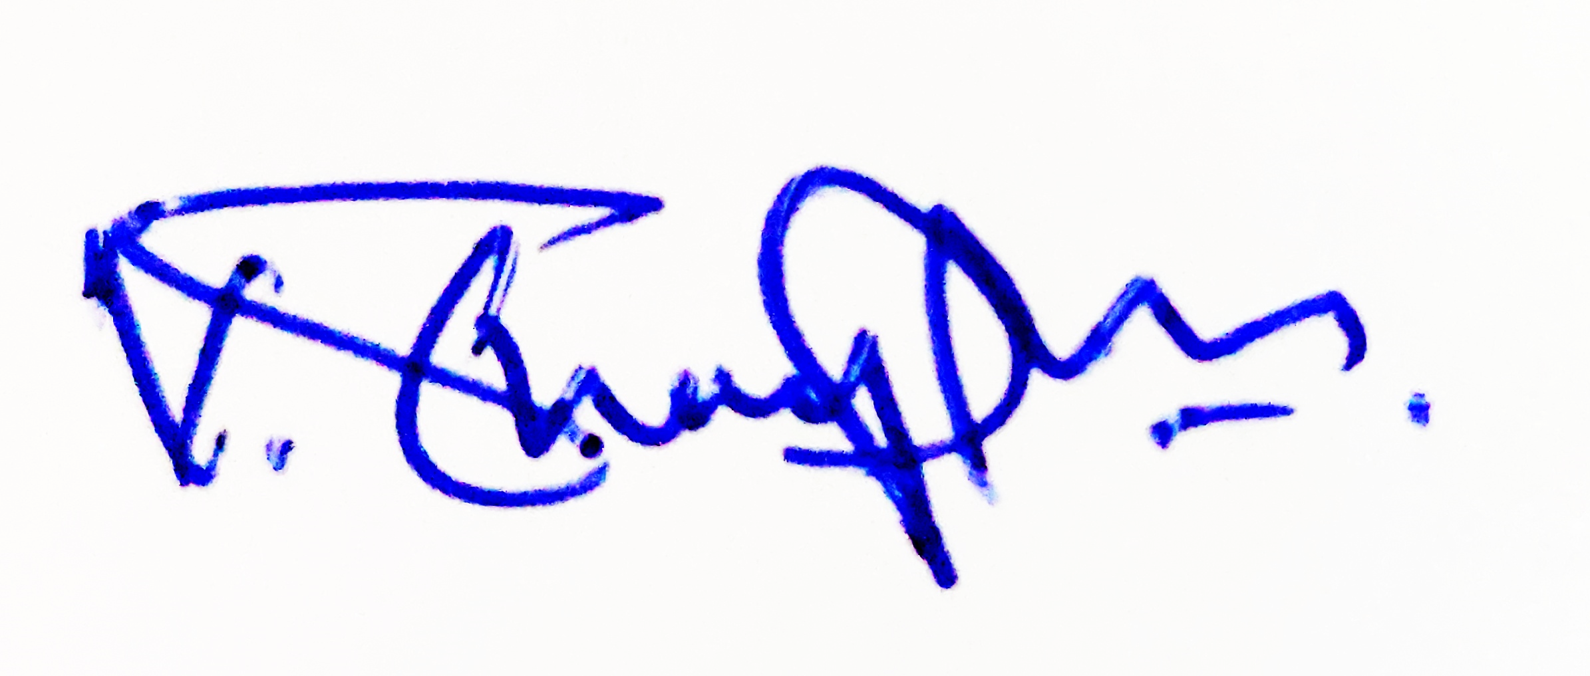

Date:14.09.2023

**(V. THANAPPAN)**