Victor Eduardo Mercado Guajardo

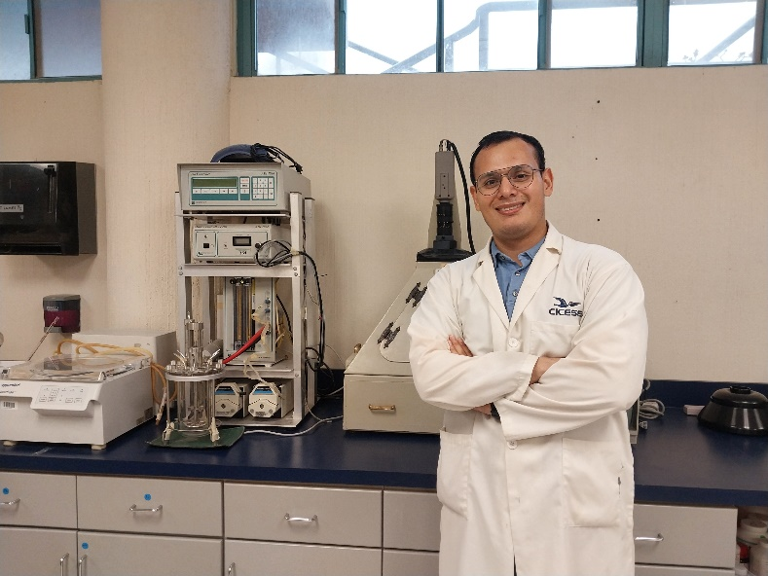Researcher

|  |  |
| --- | --- |
| **ADRESS**: Constitution 1435, Ensenada, Baja California, Mexico | [LinkedIn](https://www.linkedin.com/in/victor-mercado-guajardo-886770bb) [ORCiD](https://orcid.org/0000-0002-7748-4352) [Researchgate](https://www.researchgate.net/profile/Victor_Mercado8) |
| **PHONE:** +52 8119081666 |
| **E-MAIL:**  vicmercado93@gmail.com |

|  |  |  |  |  |  |
| --- | --- | --- | --- | --- | --- |
| **LANGUAGES** |  | |  | |  |
| Spanish - Native | English – Proficient | | German – Intermediate | | Japanese - Novice |
| **EDUCATION** |  | |  | |  |
| Ph.D in Life Sciences  CICESE 2020-2024 | | M.Sc in Microbiology  UANL 2016-2018 | | B.Sc in Biotechnology  UANL 2010-2015 | |

I am a researcher with nine years of experience in molecular biology and microbiology. Additionally, I have four years of expertise in aquaculture and animal nutrition. Over the years I have dedicated myself to laboratory work, as well as documentation management and quality control. Although I'm working on applied microbiology in animal feeds, I know that my knowledge is very useful in other fields. My dedication to my profession has resulted in positive results for the companies I have worked for. I have no problem with relocation.

|  |  |  |
| --- | --- | --- |
| **EMPLOYMENT HISTORY** | | |
| **Researcher/Ph.D. student, CICESE 2020-Present**  • Isolated and identified probiotic microorganisms and implemented them in feeds for carnivorous fishes using cheap plant-based protein, obtaining incredible weight gain and health results.  • Trained new students in good laboratory practices and trained lab technicians in molecular and microbiological techniques, improving results. In addition, I managed to publish numerous papers in high-impact journals. | | |
| **Jr. Quality Assurance, Avant Santé Research Center 2018-2019**  • Improvement in the writing of SOPs, making staff have fewer doubts about following the procedures.  • Function as English-Spanish interpreter, facilitating communication between foreign employees and clients.  • Ensure clinical protocols follow national and international standards, avoiding problems and delaying studies. | | |
| **Virtual Researcher, ReprintDesk 2016**  • Helped clients identify and find research papers on medicine, biology, and molecular biology topics and reviewed documentation for publications. | | |
| **Microbiology Technician, Centro de Capacitación en Calidad Sanitaria 2015-2016**  • Improvement of good laboratory practices and troubleshooting to identify sources of laboratory contamination.  • Participated in the identification of microorganisms and management of hazardous waste. | | |
| **SKILLS** | | |
| Time Management | Critical thinking | Microsoft Office and Computer |
| Problem Solving | Goal planning | Collaboration |
| Organization | Communication | Conflict Resolution |
| Attention to details | Data management and analysis | Management and Delegate |
| Fish handling | Feed formulation | Sample recollection |

|  |
| --- |
| **RESEARCH ITEMS** |
| 1. Macias, L; Mercado, V; Olmos, S. Assessment of Bacillus species capacity to protect Nile tilapia from A. hydrophila infection and improve growth performance. Front. Cell. Infect. Microbiol. 14, (2024). https://doi.org/10.3389/fcimb.2024.1354736  2. Mercado, V.; Olmos, J. Bacteriocin Production by Bacillus Species: Isolation, Characterization, and Application. Probiotics & Antimicro. Prot. 14, 1151–1169 (2022). https://doi.org/10.1007/s12602-022-09966-w  3. Olmos, J.; López, L.M.; Gorriño, A.; Galaviz, M.A.; Mercado, V. Bacillus subtilis Effects on Growth Performance and Health Status of Totoaba macdonaldi Fed with High Levels of Soy Protein Concentrate. Animals 2022, 12, 3422. https://doi.org/10.3390/ani12233422  4. Olmos, J.; Mercado, V. Use of alternative ingredients and probiotics in aquafeeds formulations. In Sustainable Aquafeeds, 1st ed.; Lorenzo, M.J; Simal-Gandara, J., Eds; CRC Press: London, England, 2021; Vol 1, pp. 21-55. https://doi.org/10.1201/9780429331664-2  5. Franco-Frías, E., Mercado-Guajardo, V., Merino-Mascorro, A. et al. Analysis of Bacterial Communities by 16S rRNA Gene Sequencing in a Melon-Producing Agro-environment. Microb Ecol 82, 613–622 (2021). https://doi.org/10.1007/s00248-021-01709-8 |