 | CURRICULUM VITAE
12/09/2019 | NGUYEN THI KIM YEN
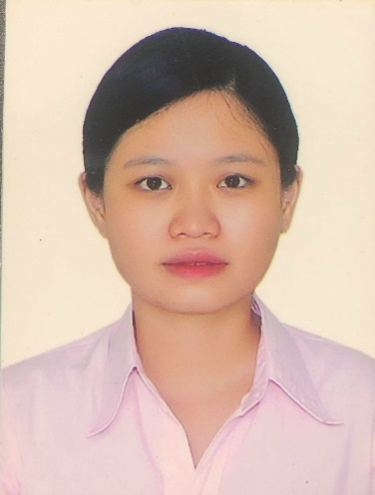 | - Applicant’s name: Nguyen Thi Kim Yen  - Date of birth: January 8th, 1994  - Home address: [home-address]
Personality | Hobbies
- Honest  - Friendly  - Responsible  - Hardworking | - Playing sports: running, badminton  - Cooking

Education background
2012-2017 | Can Tho University  Degree of Engineer  Type of degree: Very good  Major: Aquaculture  Graduation topic: Assessment on efficiency of integration forms in striped catfish (Pangasianodon hypophthalmus) cultured in Can Tho city and An Giang province, Vietnam
2017-2019 | National Taiwan Ocean University  Master Degree of Aquaculture  Specialized: Aquaculture nutrition and living organism  Graduation topic: The effects of grape extracts and organic selenium on growth performance and antioxidant status of Asian seabass (Lates calcarifer)
Additional Experience
2017 | Workplace: Viet-Anh Foreign Language Center  Address: No. 983, Area 12, Chau Van Liem Ward, O Mon District, Can Tho City, Vietnam  Job description:  English Teacher  English Courses Adviser
2012-2017 | Part-time English Tutors  Job description:  English private teaching for primary and high school students
2018/05-2019/04 | The secretary for the International Student Association at National Taiwan Ocean University
2019/01 | Presenter in Annual meeting for the Fisheries Society of Taiwan  Topic: The effects of grape extracts and organic selenium on growth performance and antioxidant status of Asian seabass (Lates calcarifer)
Certificates
Certificate of English Proficiency test
IELTS certificate (Score: 5.5)
Ministry of Education Taiwan scholarship 2017 Award Certificate (2017/09-2019/08)
Microsoft Office Certification (Cantho University)
Type of degree: Excellent
Skills
Language
Vietnamese: Native language
English: Fluent
Chinese: Fair
Microsoft Office Softwares: Fluent
Laboratory/Research Skills:
Taking care fish and shrimp
Formulating aqua-feed
Analysing proximate chemical compositions (protein, lipid, ash, moisture, fiber)
Analysing antioxidant enzyme (SOD)
Analysing Lipid peroxidation (TBARS)

