CURRICULUM VITAE

KUPPAM ANJANEYULU,  HNO: 5-61,  BOGGULAPALLI,  NALLAMADA(MANDAL),  ANANTHAPURAMU(DISTRICT),  ANDHRA PRADESH.  INDIA – 515501. | 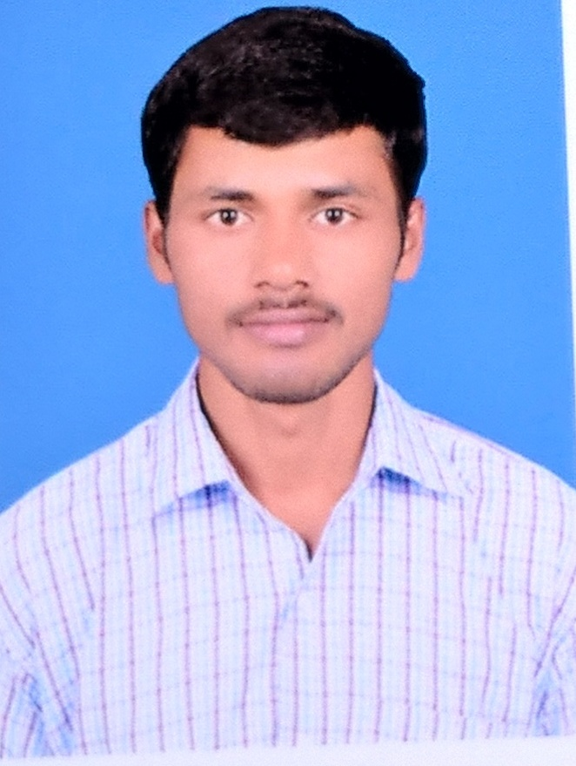  Mobile No: +919490052321  : +919491010434  E-mail: kuppamanji7@gmail.com

CAREER OBJECTIVE:
“To be a part of the challenging team which strives for the better growth of the
organization and which explores my potential and provides me with the opportunity
to enhance my talent with an intention to be an asset to the company.

CAPABILITIES:
Aiming to obtain a challenging position in a professional, artistic environment where I can use my experience in the field to benefit the organization and its clients. Capable of working with equal pace and accuracy under mental stress and pressure. Able to come up with unusual or clever ideas about a given topic or situation, or to develop creative ways to solve a problem

Qualification | University/Board | Name of the Institute | Percentage  /CGPA | Year of  Passing
M.Sc.  Zoology | Sri Venkateswara University, Tirupati | SVU College of Sciences, Tirupati | 6.4 CGPA | 2016
B.Sc.  (Botany, Zoology, Chemistry ) | Sri Krishnadevaraya University | STSN Govt., Degree College, Kadiri | 63.33% | 2014
XII  Intermediate (Bi.P.C ) | Board of intermediate education | Sri B.R.S.R. Jr., College, kadiri | 49% | 2011
X | Board of Secondary Education | Sri Balaji High school | 72% | 2009
EDUCATIONAL QUALIFICATIONS:

EXPERIENCE:

- COMPANY : CHAREON POKPHAND GROUP –CP AQUACULTURE

Designation : Technician

Duration : 2 years (From June-2016 to Still now)
EXPERIENCE IN HATCHERY:
- Sea water and Fresh water disinfection and treatments
- Follow up Section Disinfection and preparation of dry outs
- Cultivation of live feeds (ALGAE and ARTEMIA)
- Water quality management and water exchange protocols
- Periodical sampling of water and surface for Microbiological analysis
- Packing and selling of seed to the costumers
- Maintain Bio-security and 5S Skills

Shrimp handled: Lito Penneus Vennamei
Algae species : Chaetoceros Calcitrons
Thalassiosira Psuedonena
Thalassiosira Weissflogii
Skeletonema
Instruments expertise: Indoor lab (Algae seed bank preparation)
Photo Bioreactor
Biophysical operators (Autoclave, Hot air oven, Laminar Air Flow,Micro oven, Microscope etc.,)

SKILLS:

• Excellent communication skills.
• Willingness to learn, interest to work with a team of experts.
• Self-motivated and enthusiastic personality.
• Basic Computer skills like Ms Office.

TECHNICAL SKILLS:

PGDCA (POST GRADUATE DIOPLOMA IN COMPUTER APPLICATION)

PERSONAL DETAILS:
Name : KUPPAM ANJANEYULU
Date of Birth : 14-06-1994
Father’s name : KUPPAM KRISHNAIAH
Mother’s name : KUPPAM RAJANAMMA
Gender : Male
Marital Status : Unmarried
Languages Known : Telugu, English.
Nationality : INDIAN
Email : kuppamanji7@gmail.com
Mobile : +91-9490052321

